Introduction

1.1 Overview

Vehicle Management System is software which is helpful for bus operators, who wants to operate many bus trips in a day. Vehicle Management System is a windows application written for 32-bit Windows operating systems which focused in the area of adding, editing and deleting the passengers, staff and the bus routes.

In this software a person can be register as a user and he can manage the bus routes and the staff, passengers' details. He can add a bus and its details including bus route details. User can also add the details of the staff and their duty time in the system.

1.2 Purpose

vehicle management system is a software system — or platform — that serves to manage commercial fleets of vehicles, such as cars, vans or trucks — or even heavy equipment — to ensure they're utilized safely, efficiently and professionally, while making sure they're well maintained and high-performing.

There is a reason why fleet management software systems have made their way into all significant fleet managers’ offices, right? In this section, let us look at some advantages that you are likely to see while using fleet management software systems:

Real-time Tracking: Real-time tracking is essential for any fleet manager. It is only through live vehicle tracking that managers can rest assured about their consignment and asset safety and can enjoy features such as route mapping, route planning, driver behaviour analysis, and even concise reports.

Automated Operations: Fleet management software solutions help automate end-to-end functions in your fleet. Gone are the days when you had to sit down with paper and pen to make calculations, strategies, and much more.

Low Operational Costs: Fuel monitoring and route planning features help reduce operational costs in an organization. You will learn how to use the least possible resources without compromising on results.

Higher Profitability: The lower the operational costs in an organisation, the higher the profits. Moreover, fleet management software solutions allow you to gain higher profits as you get a clearer insight into how your fleet works and get to understand better operational strategies.

2.Problem Definition & Design Thinking

2.1 Empathy Map

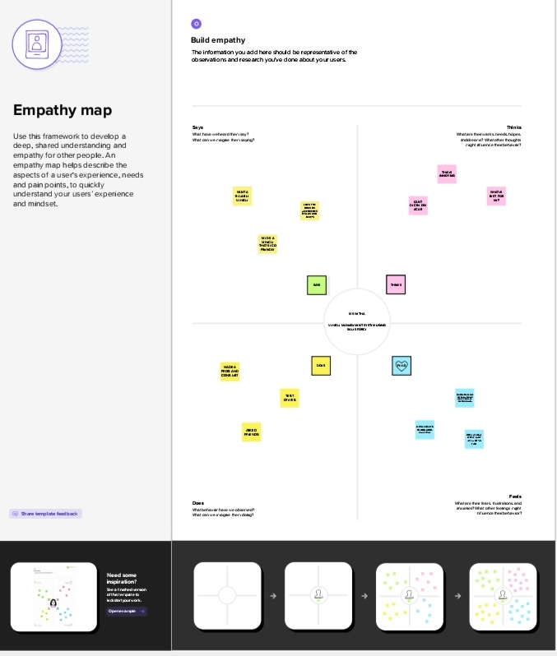

2.2 Ideation &Brainstorming Map

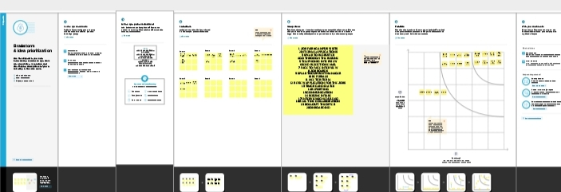

3.Result

3.1 Data Model

|  |  |
| --- | --- |
| Object Name | Field in the Object |
| Obj 1 | |  |  | | --- | --- | | Field Label | Data Type | | 2 wheeler | Picklist | |
| Obj 2 | |  |  | | --- | --- | | Field Label | Data Type | | 4 Wheeler | Picklist | |

3.2 Activity & Screenshot

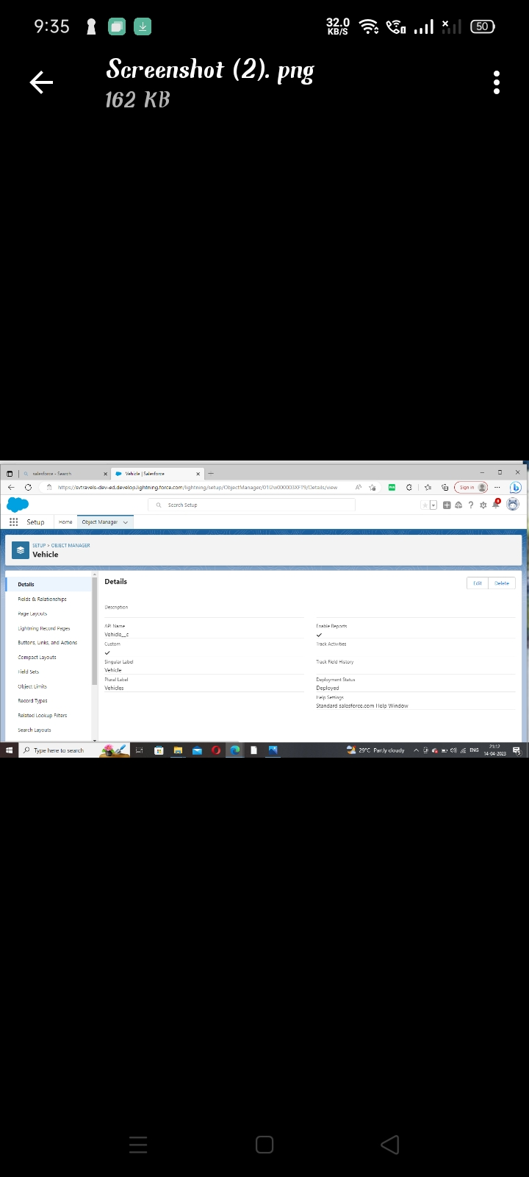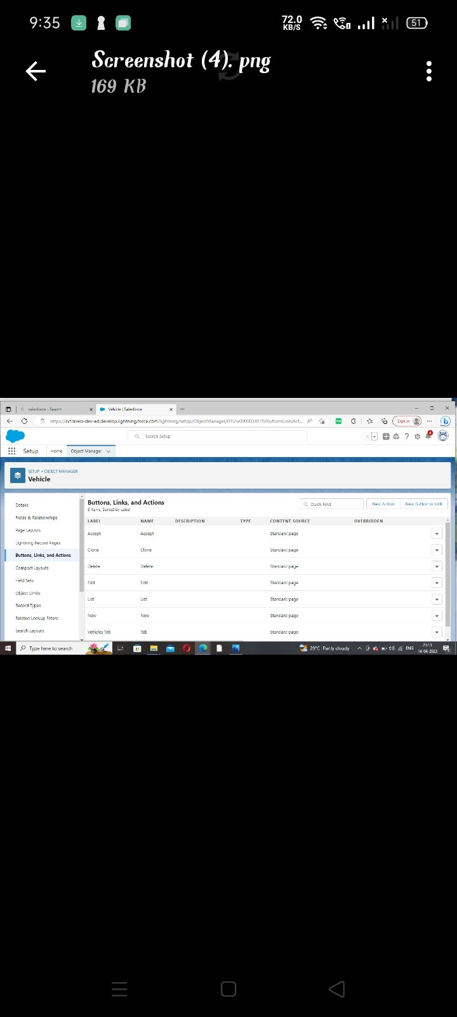

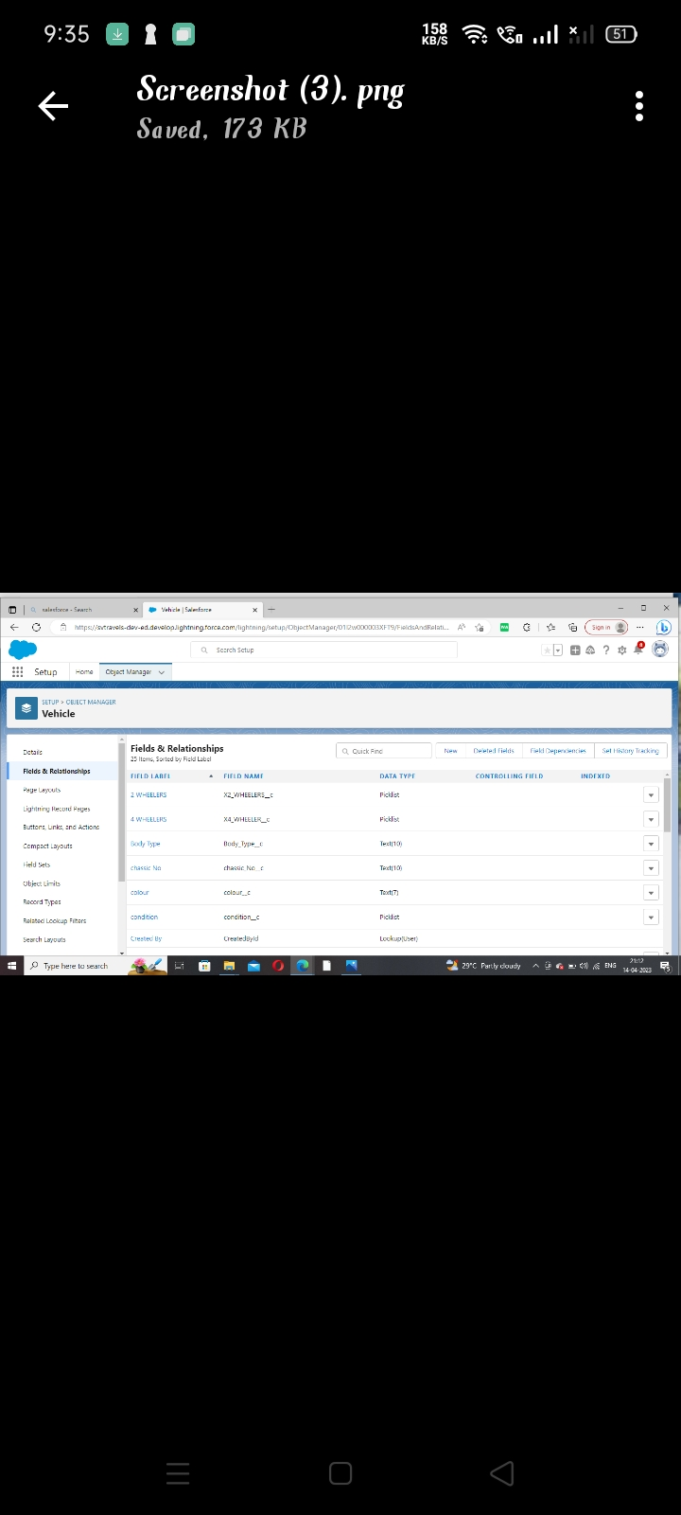

4 Trailhead Profile Public URL

Team Member -https://trailblazer.me/id/swetham3

Team Member -https://trailblazer.me/id/syadhav6

Team Member -https://trailblazer.me/id/ssuguna15

Team Member -https://trailblazer.me/id/swatv1

Project Report Template

Advantages & Disadvantage:

There is a reason why fleet management software systems have made their way into all significant fleet managers’ offices, right? In this section, let us look at some advantages that you are likely to see while using fleet management software systems:

Real-time Tracking: Real-time tracking is essential for any fleet manager. It is only through live vehicle tracking that managers can rest assured about their consignment and asset safety and can enjoy features such as route mapping, route planning, driver behaviour analysis, and even concise reports.

Automated Operations: Fleet management software solutions help automate end-to-end functions in your fleet. Gone are the days when you had to sit down with paper and pen to make calculations, strategies, and much more.

Low Operational Costs: Fuel monitoring and route planning features help reduce operational costs in an organization. You will learn how to use the least possible resources without compromising on results.

Higher Profitability: The lower the operational costs in an organisation, the higher the profits. Moreover, fleet management software solutions allow you to gain higher profits as you get a clearer insight into how your fleet works and get to understand better operational strategies.

Learning Curve: As with all software systems, fleet management software also comes with a certain learning curve. Some systems can be so complicated that without aid from the software provider, you might not unlock the true potential of the tool at hand.

Extra Cost: Sure, you are bound to gain a lot from using a fleet management software system. The profits you’ll make due to the software aid will eventually make up for the initial subscription cost. However, if you are a small business owner, the initial cost might seem like too much.

Infrastructure Needs: You’ll face issues using fleet management software systems if you don’t have proper network infrastructure. Without a stable Internet connection at all times, you will be missing out on the ‘real-time’ aspect of these systems. However, you can hardly do anything effectively without proper network infrastructure anyway.

Application:

The Vehicle Management System (VMS) is an application for the Automotive industry. It supports, in the area of Sales & Services, the business processes that you require as vehicle importer when dealing with your original equipment manufacturers (OEMs) and your dealers in new and used vehicle sales .

Conclusion:

Effective Future adjustments may be made with ease because of how the package was created. The project's development has led to the following inferences. Efficiency is increased by automating the entire system. When compared to the current system, it offers a user-friendly graphical interface that is superior. Depending on their permissions, it grants the permitted users the proper access. It successfully gets over the communication lag. Our everyday lives revolve around our cars, which require routine maintenance to function well. IoT automation makes the entire process of automotive service quick and smart. The above-mentioned technology not only keeps track of the condition of our automobile in real-time, but it also offers vital information and forecasts that enable us to estimate the cost and timing of the subsequent service. Even though this technology raises the cost of servicing, it stops service facilities from charging more and informs the client of all the modifications made to the vehicle. Overall, the consumer saves time and money with this method. The way we live and work has been dramatically changed by technologies like IoT and RPA. It has simplified our lives. This technique lessens client effort while simultaneously improving the efficiency of our automobile. Predictive analysis may be enhanced by employing AI and different performance-enhancing techniques. VI.

Future schop:

This software eliminates manual labor and any associated issues. It is a simple approach to learning more about the many products that are available at supermarkets. Well,

As we discussed earlier, connected cars are the new, shiny, up-and-coming thing in the automobile industry. With improving technology, more brands are manufacturing and launching connected cars. Considering that the tech and production are at a steady pace, road infrastructure will also be forced to improve to ensure that connected cars can be used up to their full potential. It is fair to assume that going forward, connected car technology will be the norm.